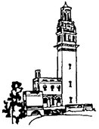
Beckford
Tower
Trust
News Release

15 November 2011

Unique William Beckford survival saved for the nation

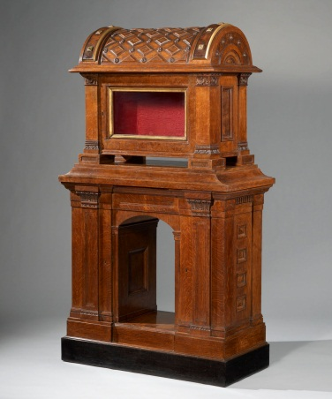
The Beckford Tower Trust has successfully secured a rare coffer cabinet and stand made for the famous and eccentric 19th century collector, William Beckford (1760-1844).
It was saved thanks to £148,000 from National Heritage Memorial Fund (NHMF), £110,000 from national fundraising charity the Art Fund along with numerous personal donations.

Dating from the 1830s, this coffer and stand is the only known complete piece of furniture from a set of four originally created for the Scarlet Drawing Room at Beckford’s Tower in Bath. Beckford was one of the most extraordinary men of his time, who inherited a vast fortune at the age of ten. He used his immense wealth to build Fonthill Abbey in Wiltshire and create one of Europe’s greatest collections of furniture books, objects and paintings. Beckford moved to Bath in 1822 and in 1827 built the Tower to house his collection. The coffer and stand was most probably designed by Beckford himself and the Bath architect Henry Edmund Goodridge (1797-1864) and was used as a display cabinet for items from Beckford’s extensive collection.

Dr Amy Frost, Curator of Beckford’s Tower & Museum, said:
“The coffer and stand is a superb example of Beckford’s impact on the history of furniture, design and collecting. Local support towards our campaign to purchase it has been wonderful and it is fantastic to return it to Beckford’s Tower and put it on public display in the building it was designed for”

The coffer and stand was subject to a temporary export bar from March this year, following recommendation by the Reviewing Committee for the export of Works of Art and Objects of Cultural interest (administered by the Museums, Libraries and Archives Council).

Culture Minister Ed Vaizey said:
“I am thrilled that the Beckford Tower Trust has managed to raise enough money to keep William Beckford’s coffer in the UK. This is a great example of why we have a system of deferring exports, and also a triumph for the kind of small scale philanthropy that we are working hard to encourage.

“It is of course very fitting that this fine piece of furniture will be on display at the Beckford Tower and Museum and I offer them my warmest congratulations on securing its future in the UK.”

Dame Jenny Abramsky, Chair of the NHMF, commented:
“This is a unique survival. Beckford continues to be highly respected as an arbiter of 19th-century national taste and that is why the trustees of the National Heritage Memorial Fund - which was set-up to safeguard our most precious heritage at risk - felt it was crucial to step in to help return this heritage treasure to its original setting.”

Stephen Deuchar, Director of the Art Fund said: “This is a wonderfully quirky piece of furniture that beautifully illustrates William Beckford’s tastes. It is great news that it has been able to remain in the UK and return to its original home where it can be seen and enjoyed by all.”

The coffer and stand is now on display alongside other items once in Beckford collection at Beckford’s Tower & Museum in Bath, open at weekends until the end of October 2011.

For more information and images contact
Dr Amy Frost
01225 460705
07732172872
beckford@bptrust.org.uk

Notes
National Heritage Memorial Fund (NHMF)
The National Heritage Memorial Fund was set up to save the most outstanding parts of our national heritage, in memory of those who have given their lives for the UK. NHMF currently receives annual grant-in-aid from the Government. It is due to receive £20million between 2011-15, allowing for an annual budget of £4m-5m. www.nhmf.org.uk.

Beckford’s Coffer and stand joins a diverse range of over 1,200 iconic objects and places which have been safeguarded by the NHMF to the tune of over £300million. These include:
- The Coenwulf Coin;
- The Macclesfield Psalter;
- The Mappa Mundi; The Staffordshire Hoard;
- The Milton Keynes Pot of Gold;
- The Mary Rose; The Flying Scotsman;
- The last surviving World War II destroyer, HMS Cavalier;
- Antonio Canova’s The Three Graces;
- Jane Austen’s unfinished manuscript ‘The Watsons’
- The Turing-Newman Collaboration Collection;
- The Frome Hoard;
- Stockholm Island, Site of Special Scientific Interest (SSSI) in Pembrokeshire.

The Art Fund
The Art Fund is a national fundraising charity, helping UK museums and galleries to buy, show and share art. It offers many ways of enjoying art through the National Art Pass which gives free entry to over 200 museums, galleries and historic houses across the country as well as 50 per cent off major exhibitions. Over the past five years, the Art Fund has given £24 million to 248 museums and galleries to buy art. It also sponsors the UK tour of the ARTIST ROOMS collection – reaching several million people each year, and fundraises: recent campaigns include bringing in £6 million to save the Staffordshire Hoard for the West Midlands and Brueghel the Younger’s The Procession to Calvary for Nostell Priory. It is funded entirely by its 80,000 supporters who believe great art should be for everyone to enjoy. Find out more about the Art Fund and how to buy a National Art Pass at www.artfund.org

