3 June 2015

Bath’s No.1 Royal Crescent offers parents free baby carriers, provided by BabyBjörn®

The latest offer from this family-friendly museum

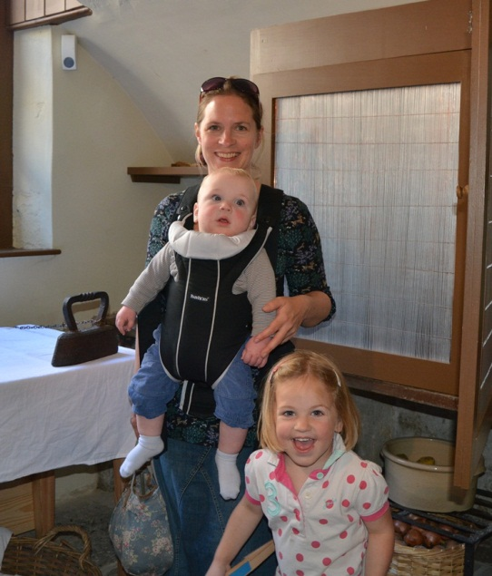
No. 1 Royal Crescent won the Gold Award for Access and Inclusivity at the South West Tourism Awards 2015, but is continually seeking ways to improve its welcome to visitors. A recent initiative is to lend parents or guardians visiting with a baby a baby carrier, generously donated by BabyBjörn®.

Visitor feedback is already very positive, with parents grateful for the free loan. During last week’s half term, Mums reported that the baby carriers enabled them to enjoy the museum in comfort, allowing them to have their hands free, and concentrate on other family members as they walked around. It is not unusual for pushcairs and prams to be banned from museums, but at No. 1 parents can transfer infants to the baby carriers, often without waking them up. Babies over 6 months can face outwards so parents can talk them through the exhibits, too.

There is an indoor place for buggies to be parked, and other facilities include a baby-changing station and soft chairs for breastfeeding and bottle feeding, either in the public areas or a quieter spot. A lift takes visitors to two floors, including the Brownsword exhibition gallery.

There are several‘hands on’ activities for children; these can mainly be found in the Gentleman’s Retreat and the Servants’ Hall. ‘History Detective’ packs are available free at the ticket desk. They contain activities aimed at children aged 4+. There are also Georgian themed games, books and try-on costumes in the Servants’ Hall. For the duration of the Small Worlds exhibition of historic dolls’ houses, two modern dolls’ houses are located in the Servants’ Hall for children to play with.
MEDIA CONTACTS:

Janey Abbott, Communications Officer, Bath Preservation Trust

Telephone: +44 (0)1225 338727 jabbott@bptrust.org.uk
Nikki Fox, Press Officer, BabyBjörn
Telephone: +44 (0) 844 8154 813 NikkiFox@clareville.co.uk

Notes for editors

www.no1royalcrescent.org.uk
No.1 Royal Crescentoffers visitors from all over the world the chance to explore the recreated historic interiors of a late 18th century Bath Town House of distinction. With 10 fully-dressed heritage rooms, additional halls and galleries, an education centre, a well-stocked shop and free introduction room, the house reveals what life was really like for our ancestors – upstairs and downstairs – nearly 250 years ago.

The imaginative approach to the ways in which the house can now be interpreted, together with its excellent accessibility and the quality of its permanent collections, have each been recognised with national awards since its reopening in 2013.

The museum receives some 60,000 visitors per year. During the past 12 months it has won:
- Gold Award for Access and Inclusivity at the South West Tourism Awards 2014/15
- ‘Highly Commended’ for the Best Large Visitor Attraction at the South West Tourism Awards 2014/15
- 'Highly Commended' at the 2014 Museums+Heritage Awards for Best Permanent Collection
- Sandford Award 2014. Sandford Awards recognise the quality and excellence of education programmes run at historic sites and are ratified by the Heritage Education Trust
- Best Leisure and Tourism Business Award at the Bath Business Awards 2014
- Best Visitor Attraction in the over 50,000 visitors per year category at Bath's Events, Hospitality and Tourism Awards 2014
- Certificate of Excellencefor 2011, 2012, 2013, 2014 and 2015by Trip Advisor

Its major exhibition in 2015 is “Small Worlds: Historic Dolls Houses from the 18th and 19th Centuries”. It showcasesLiza Antrim’s remarkable private collection which has never before been on public display. It runs until 8 November.

About BabyBjörn
www.babybjorn.co.uk

BjörnJakobson developed the bouncer and started the company BabyBjörn AB in the 1960s. He was inspired by the new research into the importance of closeness and began to develop a baby carrier in collaboration with paediatricians. A baby carrier should promote closeness and strengthen the bond between parents and their newborns, while functioning as a practical everyday aid. BabyBjörn launched its first baby carrier, "Hjärtenära" (Close to your heart), in 1973.

We have been happy to donate several baby carriers to No. 1 Royal Crescent. They can be adjusted to provide babies with the correct head and neck support. You only need to fasten a few buckles to carry your baby comfortably and securely. The colour-coded buckles and safety click ensure that the baby is fastened in correctly. The baby carrier can be easily adjusted for a perfect fit.

