PRESS RELEASE
For immediate release: 18.07.12

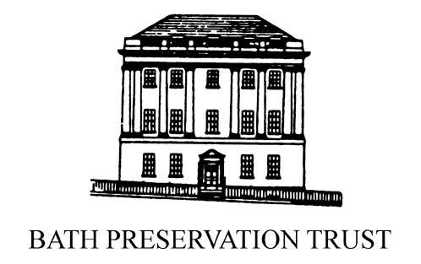
Learn the Art of Sugar Sculpture
Held at the Building of Bath Collection and in association with the Great Bath Feast
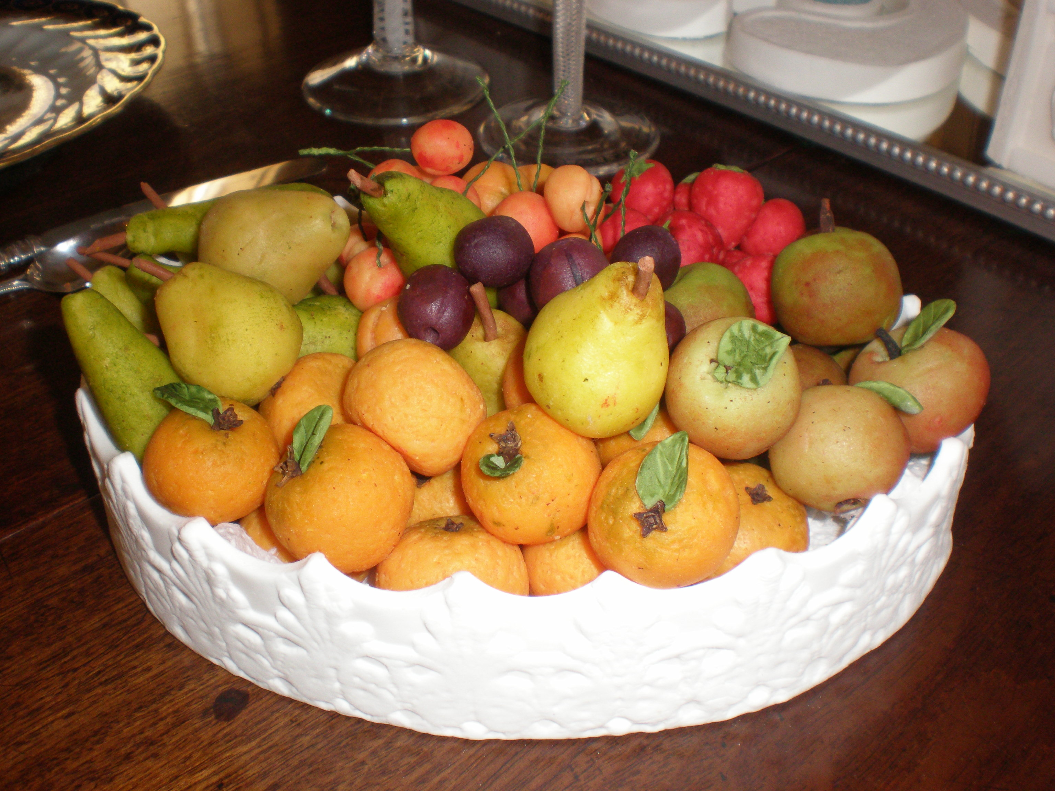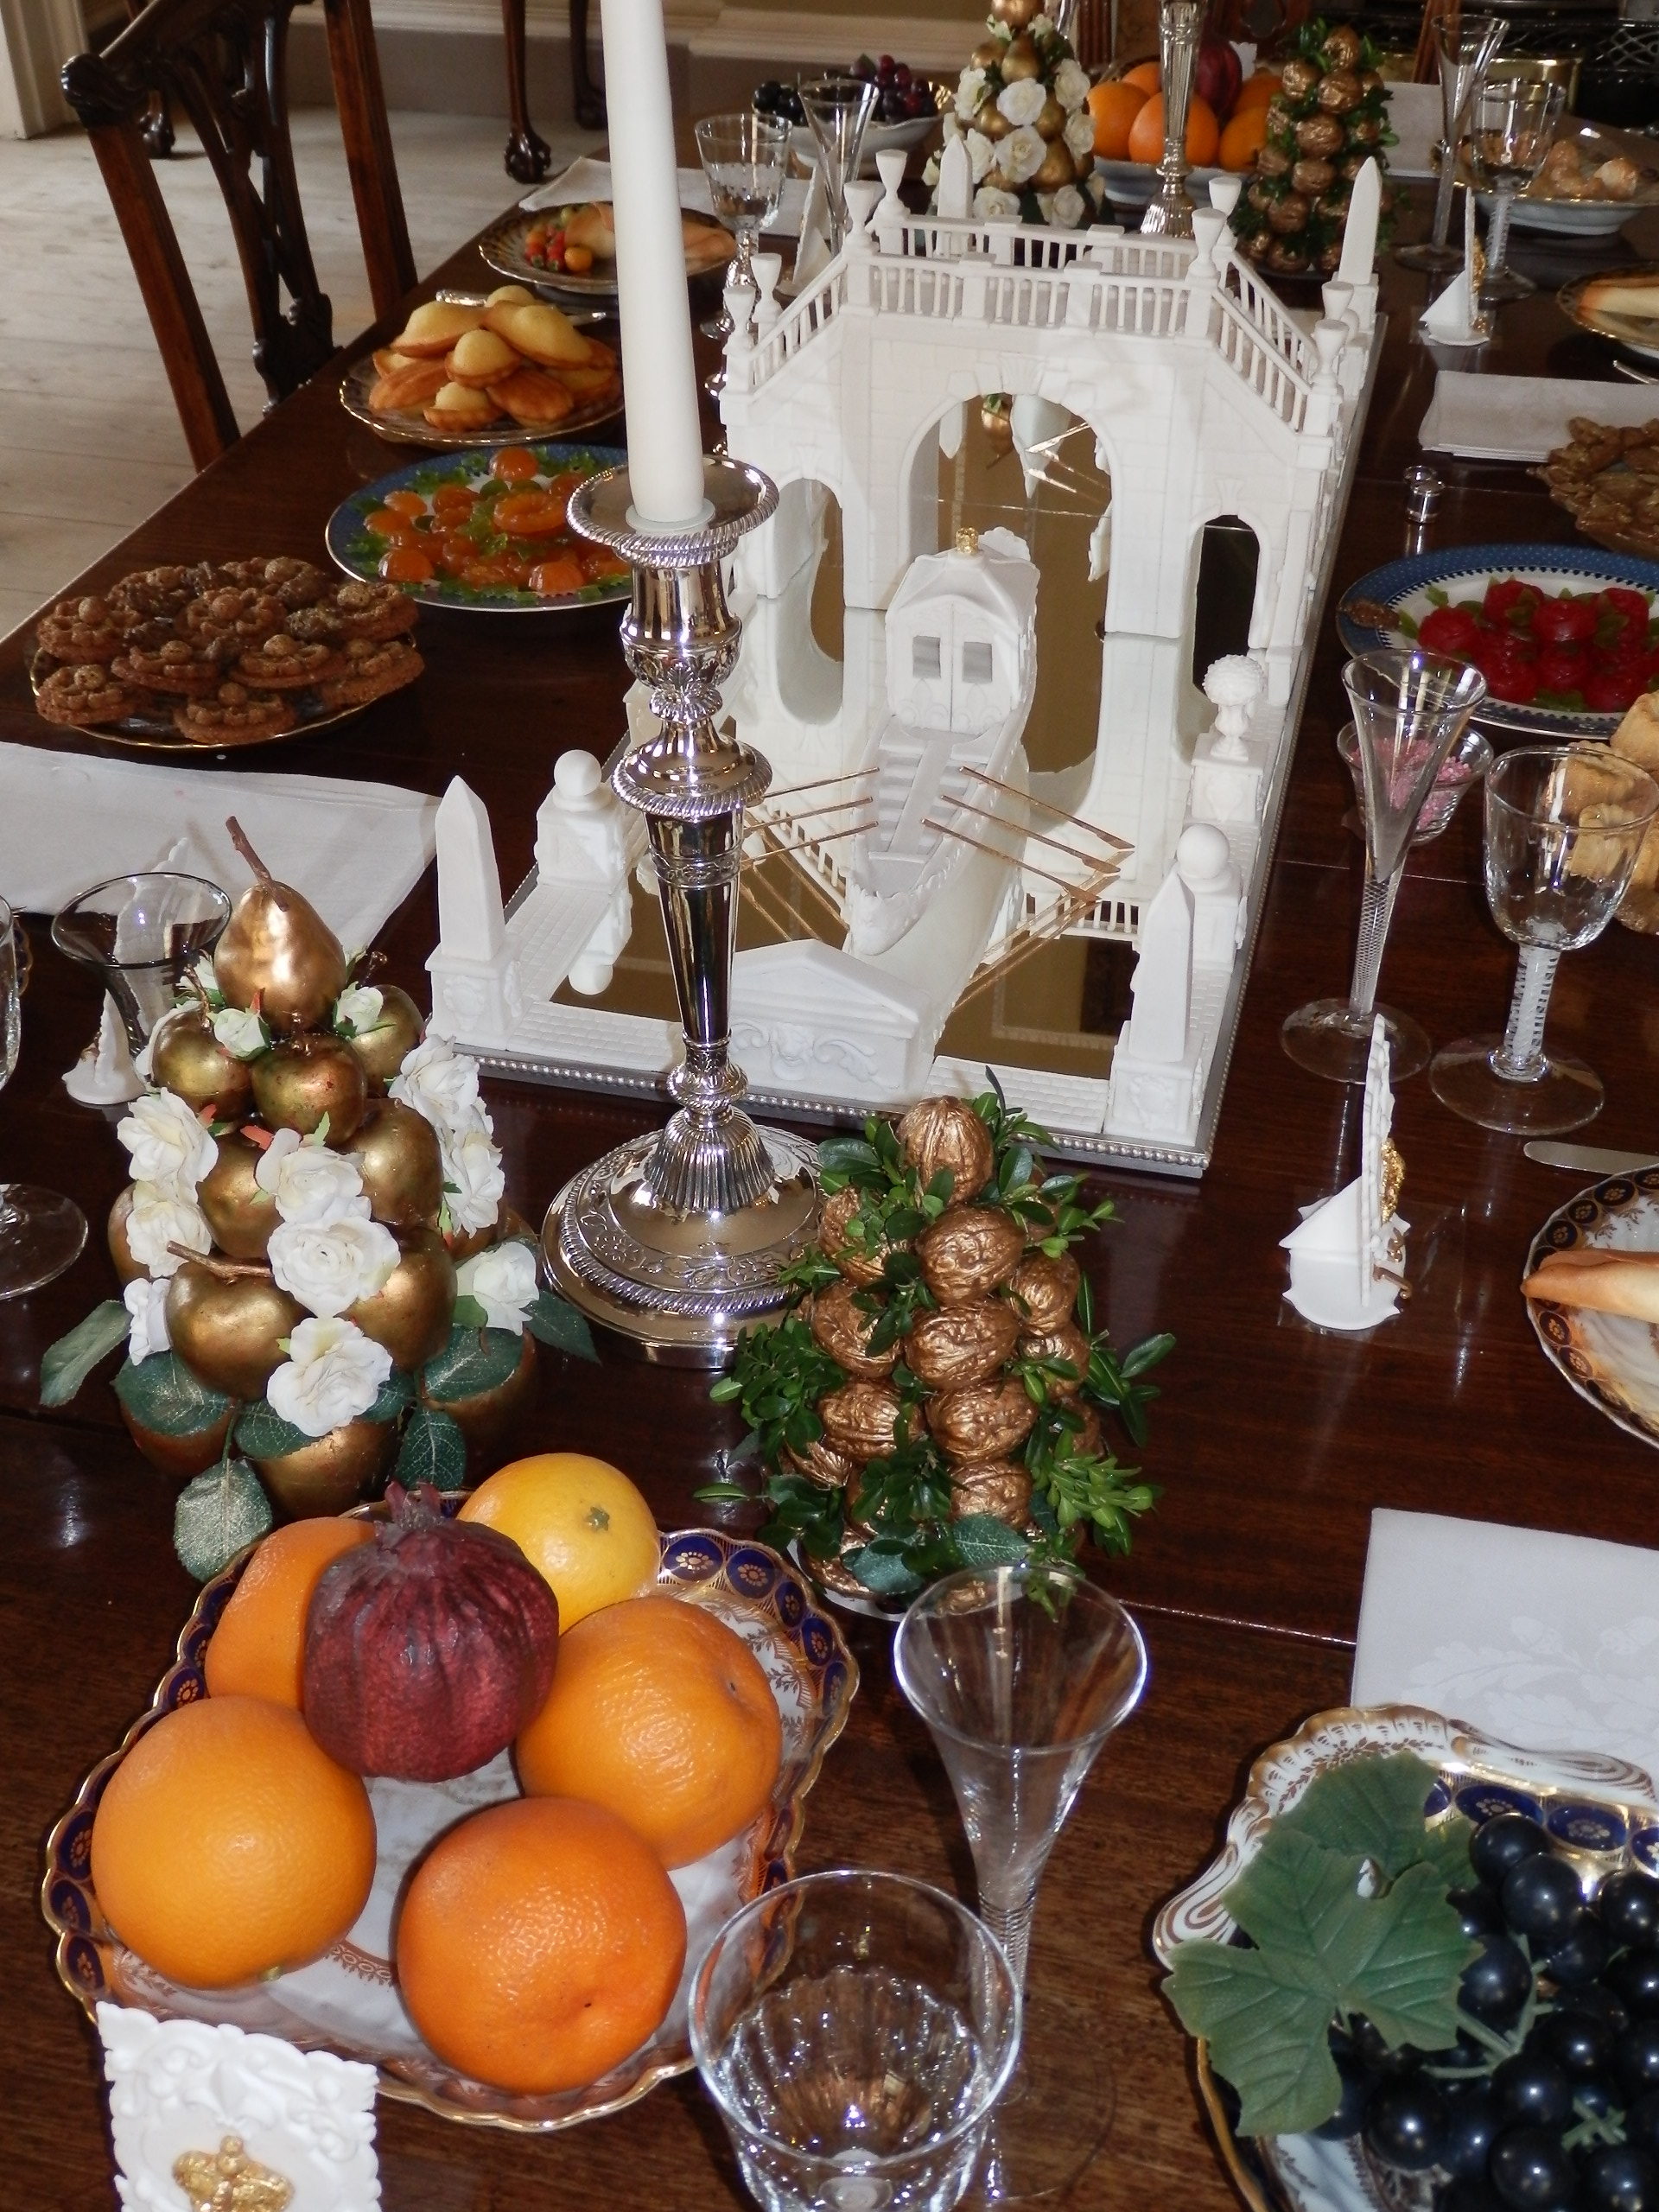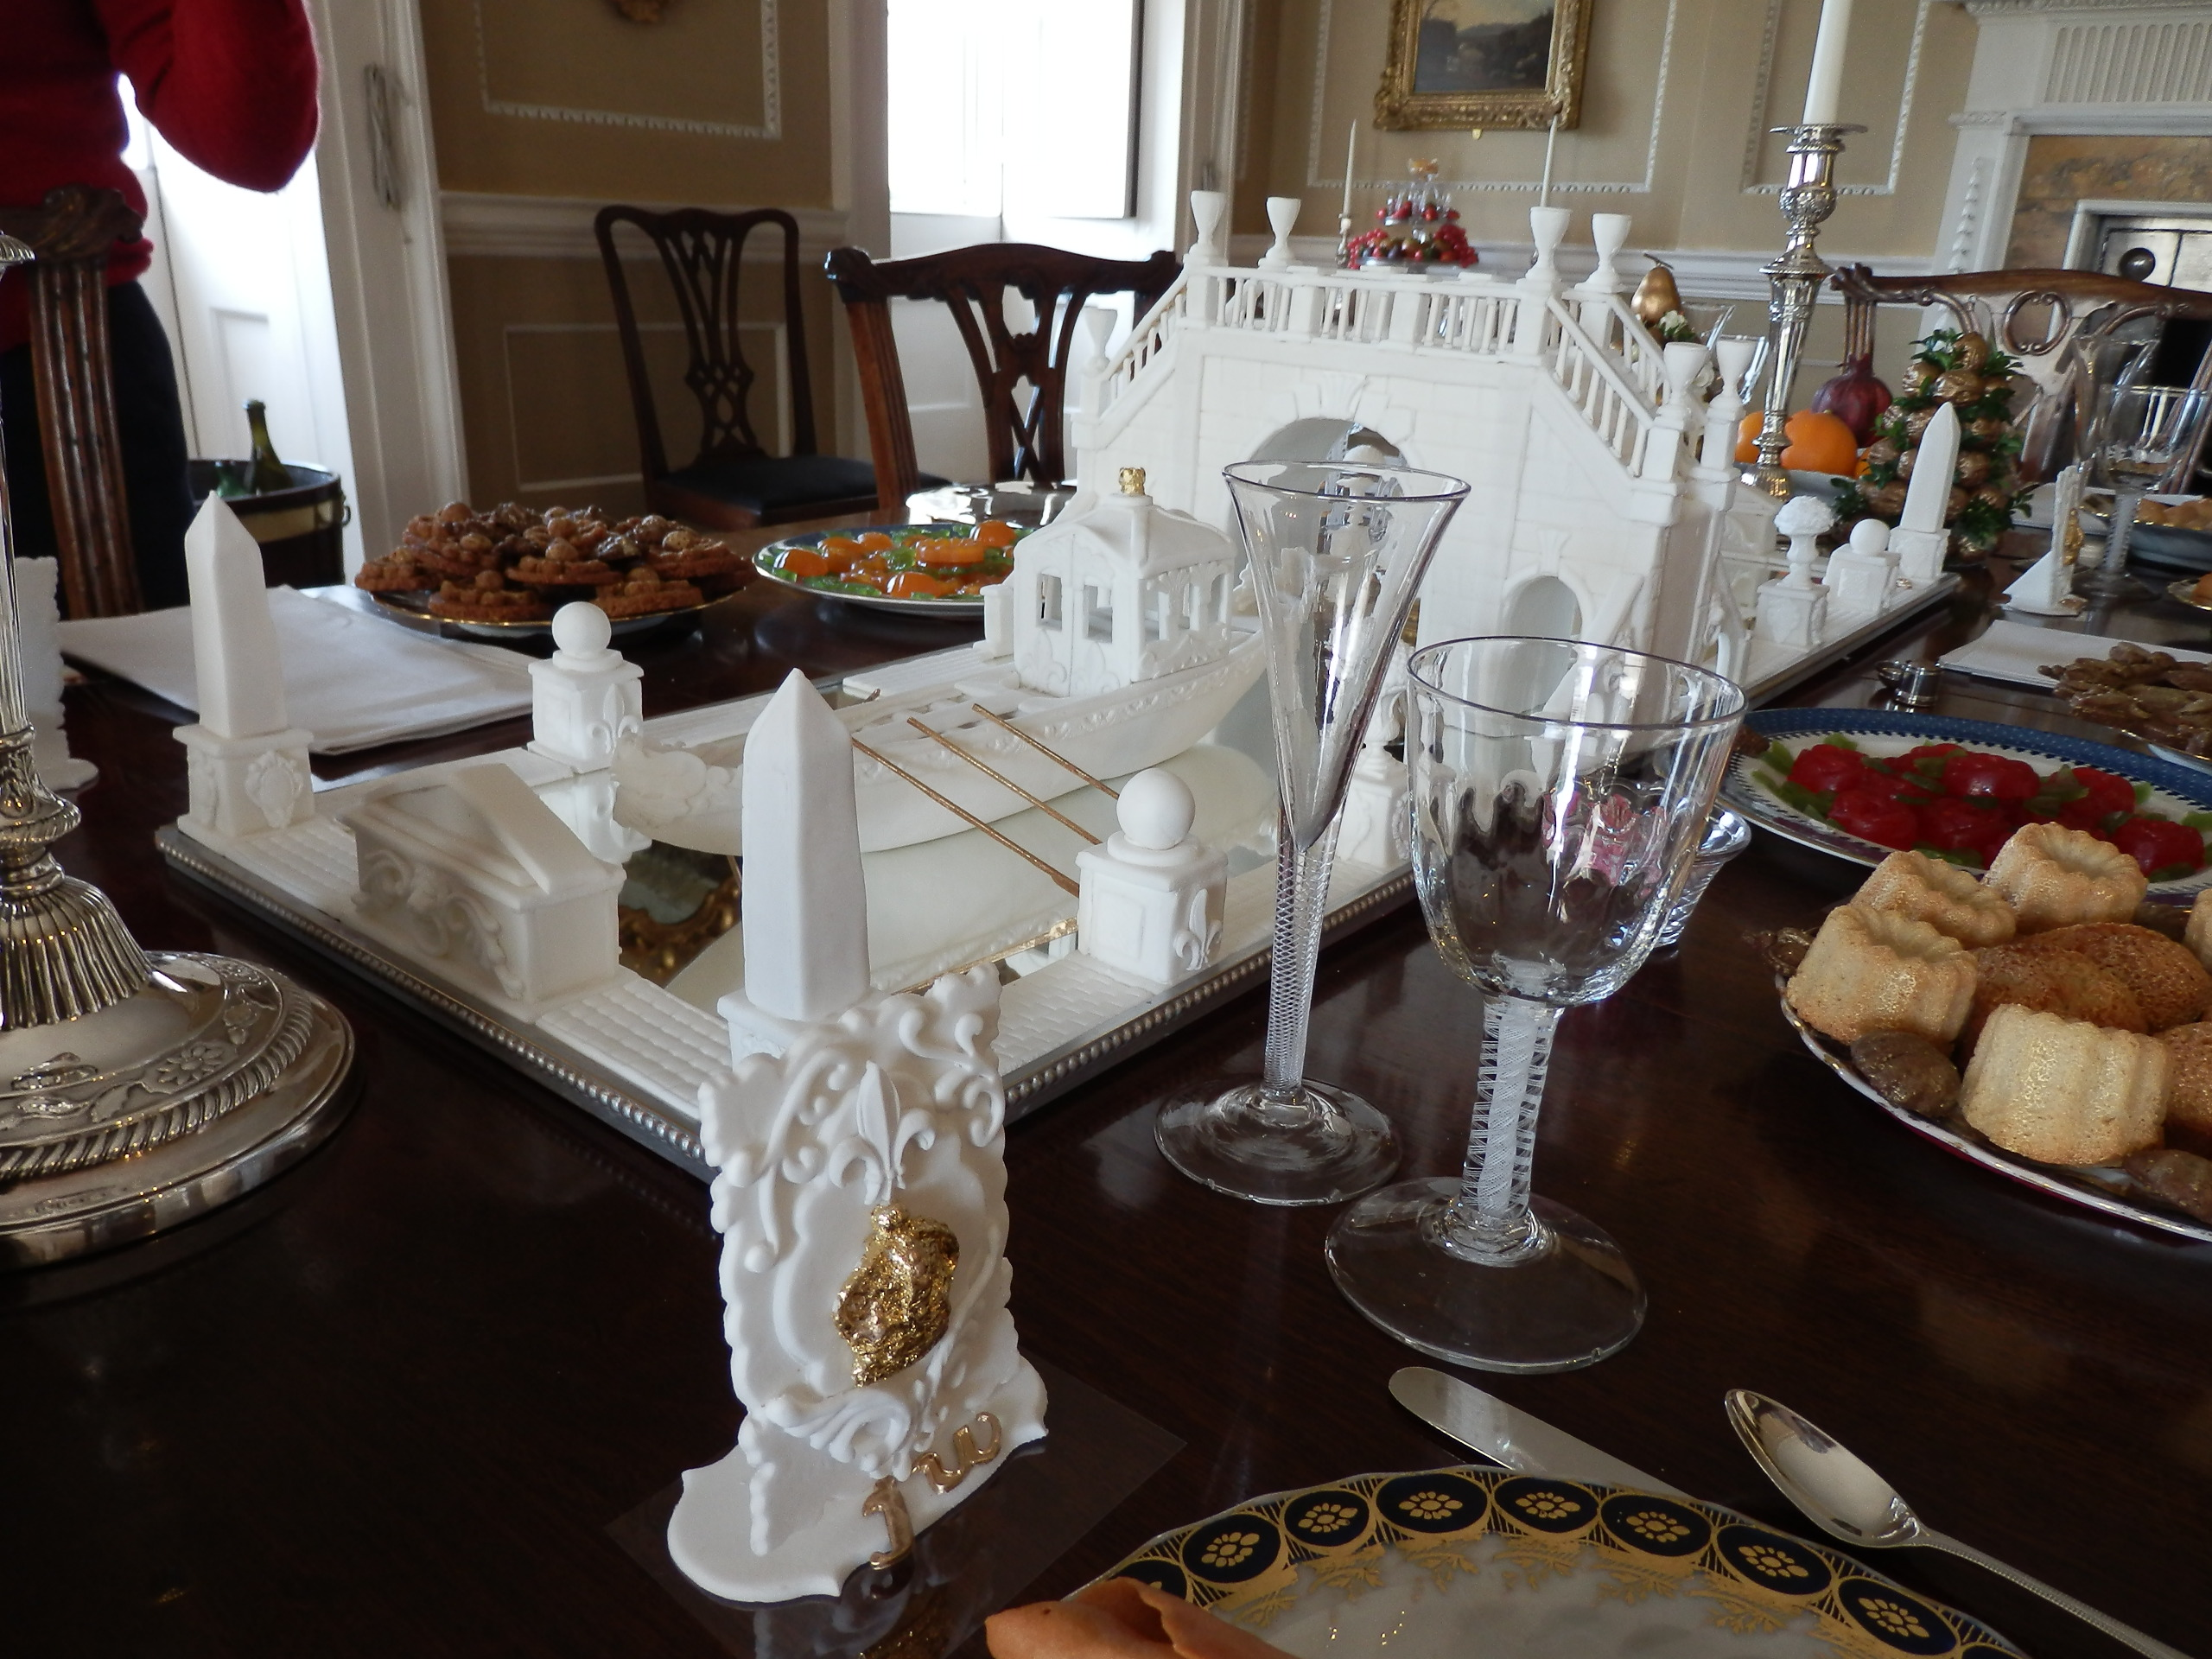

Gain valuable and practical experience in the 18th Century art of sugar sculpture with our talented artist Jean Boardman.

Join us as we spend this exclusive afternoon workshop between 2-4pm on Thursday 11 October learning the best methods and techniques for creating exquisite table top displays. There will be an opportunity for everyone to make their own sugar box filled with delicious sweetmeats and an initialled place marker to take home. These items make the perfect finishing touch to every dinner party’s dining room table. Just don’t be tempted to eat them before your guests arrive!
Over the past few years Jean Boardman has designed a number of sugar sculpture displays for No.1 Royal Crescent’s dining room table, including a very elegant river procession sculpted from sugar for the Diamond Jubilee. Highly regarded and extremely dedicated, you will not want to miss your chance to be taught by Jean, whose enthusiasm and talent will have you inspired to produce your own wonderful displays.
A great opportunity to get an early start on making beautiful homemade gifts in time for Christmas!

Tickets for this special event cost £20 per person
All sugar materials will be supplied and light refreshments will be provided, however please bring the following equipment for your use during the afternoon:
- Rolling Pin
- Board for rolling
- Palette Knife
- Plastic Tupperware box to take home your sculptures

To book your place or for further information please contact 01225 428126 or email Kate krogers@bptrust.org.uk

- Ends -

All media enquiries to:
Janey Abbott
Tel: 01225 338727 Email: jabbott@bptrust.org.uk

Editors’ Notes:
- Please note that visitors will need to book for this event.
- This event takes place at the Building of Bath Collection, The Countess of Huntingdon’s Chapel, Paragon, Bath BA1 5NA on Thursday 11 October 2012, 2-4pm
- Images are available on request from Kate Rogers at krogers@bptrust.org.uk.
- A full listing of future Bath Preservation Trust events can be found at www.bptlearning.org.uk under events calendar.
- Jean Boardman is currently one of No.1 Royal Crescent’s dedicated museum volunteers.
- Would sugar sculptured displays have been eaten in the 18th Century? – probably not. They were normally just for show. Sugar was not usually coloured – the whiter the sugar, the more expensive. Specialist confectioners were commissioned to make the displays.

