For immediate release
No. 1 Royal Crescent dares to lift the skirts
on Jane Austen’s Women!

A genteel townhouse museum in the heart of Bath is boldly taking on the city’s most famous resident, Jane Austen and daring to bust some myths about the sexual mores of her time.

It wasn’t all tea parties, country balls and chaste courtship. No. 1 Royal Crescent’s new exhibition Portrait of a Lady?: Ruin and Reputation in the Georgian Era exposes the harsh realities for women and how they often used sex to better their lives and prospects.

The exhibition, curated by renowned 18th century historian and broadcaster, Hallie Rubenhold, busts myths and stereotypes about morality in the past, including:

* Men married their mistresses
* Prostitutes and actresses frequently married titled gentlemen
* No one could rise as quickly through the ranks of society as a young woman prepared to sell herself
* Titled gentlewomen frequently fell from their pedestals to live as courtesans

There hasn’t been an exhibition of its kind before in Bath and it’s intended to raise some eyebrows among the Austen enthusiasts who regularly flock to the city to pay homage to the author of Pride and Prejudice.

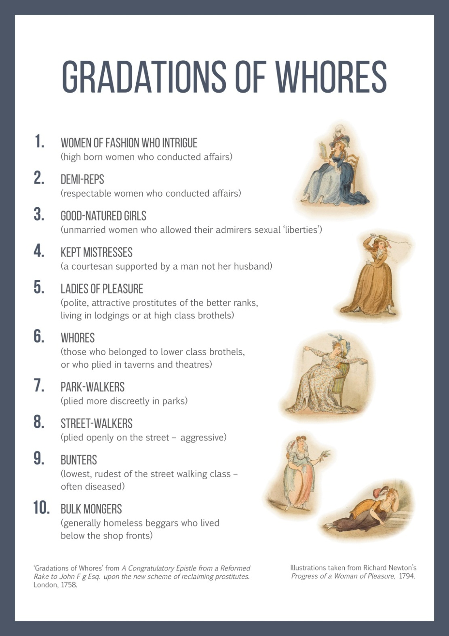

Bath Preservation Trust’s Head of Museums, Tom Boden, says:
‘It’s a far cry from most people’s perceptions of the era and therefore this is very much part of the museum’s remit to inform and educate.’

‘Through TV and film we’ve been bombarded by genteel images of life for women in Austen’s era which is misrepresentative of the reality. We hope to shock a few people into a better understanding of history ’, says Rubenhold.

This exhibition is supported by the Heritage Lottery Fund and by George Bayntun.

-Ends-

For further information please contact:

Janey Abbott, Communications Officer, Bath Preservation Trust

Telephone: 01225 338727 Email: jabbott@bptrust.org.uk

Notes for editors www.no1royalcrescent.org.uk
No.1 Royal Crescent enables people to explore the recreated historic interiors of a late 18th century Bath Town House of distinction. Built on the realistic presentation of authentic historic objects in period room settings, No.1 deploys a wide range of interpretation to bring the house to life for all visitors.

Following a major redevelopment, the museum re-opened in June 2013 and now has twice as many historic rooms as well as a dedicated exhibition gallery. The museum receives approximately 60,000 visitors per year and is currently ranked by Trip Advisor as the second best museum in Bath, behind the Roman Baths.

Entry to the exhibition is free with normal admission to the museum or £4.00 (no concessions) for visitors to the exhibition only.

Highly Commended at the 2014 Museums and Heritage Awards in the Best Permanent Exhibition category. Second only to The New Mary Rose Museum.

Seriously George-dropping museums

You may wish to feature the exhibition in tandem with a Bath Museums Partnership initiative promoting all 17 of the City’s museums and linking them via the tercentenary of the Georgian Era.

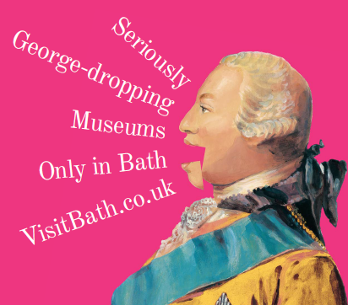
Website link

