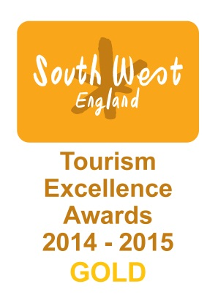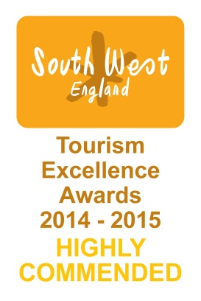

13 February 2015

Double winners at South West Tourism Awards 14/15!

No.1 Royal Crescent in Bath won an illustrious Gold Medal in the Access and Inclusivity category at last night’s South West Tourism Awards, as well as a Highly Commended Certificate for Best Large Visitor Attraction in the region.

When No.1 was renovated in 2012/13 it had been a priority to make this Grade 1 listed building as accessible as possible, inserting a lift, hearing loops, special lighting and signage, braille guides, a virtual tour on iPads, floor plans for wheelchair users and room sheet translations in 24 languages. Staff and volunteers undergo training in customer care and hospitality for visitors of every nation and ability, and ‘secret shoppers’ sent by the judging committee reported exemplary treatment.

Bath Tourism Plus profiled No.1 as Bath’s most accessible museum in an Access for All campaign it ran in 2013.

No. 1 Royal Crescent is a Georgian townhouse museum built on arguably Europe’s finest crescent, offering visitors a glimpse into the lives of its original residents – both upstairs and downstairs - when it was built nearly 250 years ago. Since reopening in June 2013 the museum has won:
- Gold Medal for Access and Inclusivity at the South West Tourism Awards 2014/15
- Highly Commended for the Best Large Visitor Attraction at the South West Tourism Awards 2014/15
- Highly Commended at the 2014 Museums+Heritage Awards for Best Permanent Collection
- Winner of the Best Large Visitor Attraction at Bath’s Events, Hospitality and Tourism Awards 2014
- Winner of the Leisure and Tourism Award at the Bath Business Awards 2014
- A Sandford Award 2014 for our education programmes
- A 2014 Certificate of Excellence by Trip Advisor
- Accredited as a VisitEngland Quality Assured Visitor Attraction

Collecting the award Dr Amy Frost, Architectural Curator of Bath Preservation Trust which runs No. 1 Royal Crescent and three other Bath museums said:
“We couldn’t be more delighted with the recognition these various award bodies have afforded our recently renovated museum. To be considered one of the most accessible tourist attractions in the South West is incredible when – before the major works started – a wheelchair user could not even get to the front door! As always, this award plus our Highly Commended Certificate for Best Attraction are due to the work and foresight of a great many people who all share in our thanks. We’d also like to thank the sponsors of these awards, Purple Cloud Consultancy and Take One Media. It’s been a great night!”

- Ends -

For further information please contact:

Janey Abbott, Communications Officer, Bath Preservation Trust

Telephone: 07967440849 Email: jabbott@bptrust.org.uk www.no1royalcrescent.org.uk

or Caroline Kay, BPT Chief Executive, ckay@bprust.org.uk 01225 338727

Notes for editors

No.1 Royal Crescent enables people to explore the recreated historic interiors of a late 18th century Bath Town House of distinction. Built on the realistic presentation of authentic historic objects in period room settings, No.1 deploys a wide range of interpretation to bring the house to life for all visitors.

A visitor from Chatham, Kent, in December 2014 wrote on Trip Advisor:
“We took a tour of this lovely building. It has been beautifully restored and being a wheelchair user it is mostly accessible. I was given a "virtual" tour on an iPad of the areas I couldn't get too. The staff were so friendly and helpful. Special thanks to Charlotte, Barbara, Jessie and Richard. If you are going to Bath it really is well worth a visit.”
Paralympian Ben Rushgrove and friend tested No. 1 Royal Crescent’s accessibility credentials for a Visit England Access for All campaign in 2013. No.1 was held up as a flagship venue for accessibility throughout that campaign. Ben has 23 Gold Medals so we have a way to go to catch up but we’re extremely proud of this first one!
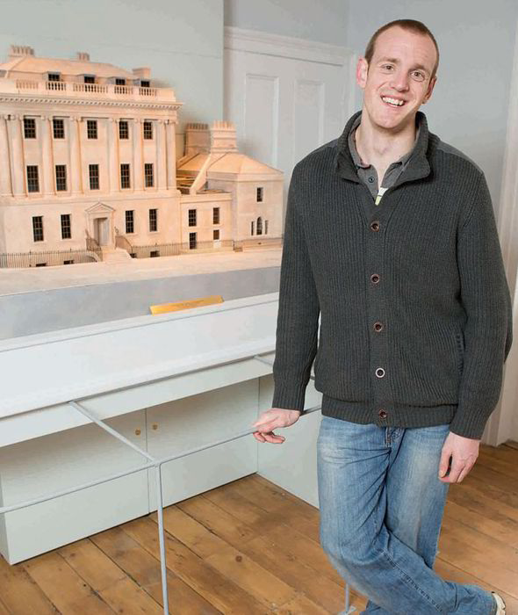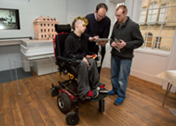

Following a major redevelopment, the museum re-opened in June 2013 and now has twice as many historic rooms as well as a dedicated exhibition gallery – the Brownsword Gallery. The museum receives approximately 60,000 visitors per year and is currently ranked by Trip Advisor as the second museum in Bath, behind the Roman Baths.

A dedicated education and events centre enables an extensive programme of learning and outreach activities, with opportunities to dress up, handle objects and learn 18th century skills such as writing with a quill and cooking.

No. 1 Royal Crescent is open 10.30am-5.30pm every day, except Mondays, when open 12noon – 5.30pm. Adult tickets cost £9, children £4 and family and concession tickets are available. www.no1royalcrescent.org.uk

No. 1’s current exhibition Saving Bath: what was saved and what was lost whilst looking at the challenges yet to come, finishes on 17 April, as does a mini exhibition of the Crescent’s key residents and restorations over the past 240 years.

On 9 May our blockbuster exhibition opens:

