15 October 2015

No. 1 Royal Crescent celebrates Hall of Fame award
Volunteer Guides are rated 5 stars by Trip Advisor reviews which earns the museum top class accolade.
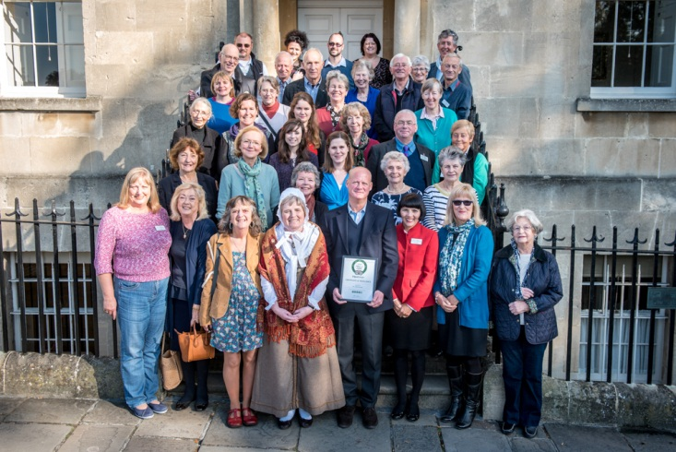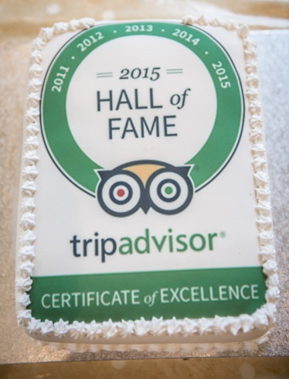
Trip Advisor started awarding Certificates of Excellence to attractions (and restaurants, hotels and B&Bs, etc.) in 2010, recognising those who consistently earned 5 star reviews from visitors. Right from the start visitors to No. 1 – both tourists and Bath residents - have raved about their visit, and the majority mention the room guides as being wonderful and bringing the house – and its stories – to life. Nearly 200 people volunteer at the museum.
So 2015 is the fifth year Trip Advisor has been awarding Certificates of Excellence, and because a very small number of businesses have earned one every year they decided to introduce a special club – a “Hall of Fame” – for these top destinations. And No. 1 is one of them! Just 9% of ALL businesses – so not just visitor attractions – are in this category.
Edward Bayntun-Coward, Chairman of Bath Preservation Trust which owns and operates No. 1 Royal Crescent, congratulated the guides at a special coffee morning with celebratory cake. He read out some Trip Advisor reviews from the previous week – all five stars:
A must see when you are in Bath - very interesting house and very informative guides providing a fascinating insight into Georgian life.
The museum recreates the house as it would have been at the peak of Bath's spa popularity. The guides in each room were knowledgeable, very friendly and informative.
The house is lovely and there were separate guides in each room, and they really knew their stuff. They could point out objects of interest and explain their use. You got to see both upstairs and downstairs too.
The President of Trip Advisor said this new Hall of Fame level was to let the best businesses – both large and small – shine and stand out from the competition.
MEDIA CONTACT:

Janey Abbott, Communications Officer, Bath Preservation Trust

Telephone: +44 (0)1225 338727 jabbott@bptrust.org.uk

Notes for editors

www.no1royalcrescent.org.uk
No.1 Royal Crescentoffers visitors from all over the world the chance to explore the recreated historic interiors of a late 18th century Bath Town House of distinction. With 10 fully-dressed heritage rooms, additional halls and galleries, an education centre, a well-stocked shop and free introduction room, the house reveals what life was really like for our ancestors – upstairs and downstairs – nearly 250 years ago.

The imaginative approach to the ways in which the house can now be interpreted, together with its excellent accessibility and the quality of its permanent collections, have each been recognised with national awards since its reopening in 2013.

The museum receives some 62,000 visitors per year. During the past 12 months it has won:
- Gold Award for Access and Inclusivity at the South West Tourism Awards 2014/15
- ‘Highly Commended’ for the Best Large Visitor Attraction at the South West Tourism Awards 2014/15
- 'Highly Commended' at the 2014 Museums+Heritage Awards for Best Permanent Collection
- Sandford Award 2014. Sandford Awards recognise the quality and excellence of education programmes run at historic sites and are ratified by the Heritage Education Trust
- Best Leisure and Tourism Business Award at the Bath Business Awards 2014
- Best Visitor Attraction in the over 50,000 visitors per year category at Bath's Events, Hospitality and Tourism Awards 2014
- Certificate of Excellencefor 2011, 2012, 2013, 2014 and 2015by Trip Advisor

Its major exhibition in 2015 is “Small Worlds: Historic Dolls Houses from the 18th and 19th Centuries”. It showcases Liza Antrim’s remarkable private collection which has never before been on public display. It runs until 8 November.

