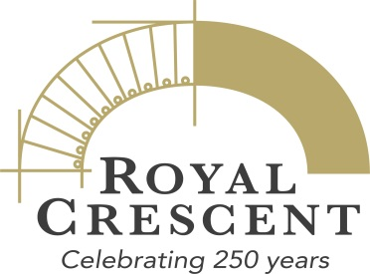

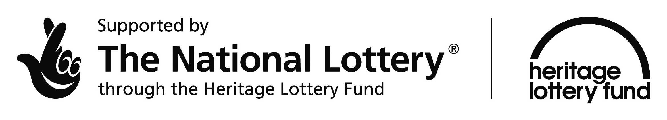

10 January 2017
Bath Preservation Trust wins National Lottery support for Royal Crescent 250th anniversary

Today, Bath Preservation Trust has received a grant of £69,200 from the Heritage Lottery Fund (HLF) for an exciting city-wide project the Trust will lead throughout 2017, to celebrate the 250th anniversary of the Royal Crescent in Bath.

No other building better represents the architectural innovation, social identity and creative imagination of Georgian Britain than the Royal Crescent in Bath. The foundation stone for this masterpiece of eighteenth century design was laid on 19th May 1767 and since then it has become one of the most famous buildings in Britain. It stands as a doorway through which the history of the Georgian period can be discovered and the architecture of the future inspired.

The project will include exhibitions, debates, community events, guided walks and artworks exploring the enduring power of a single building. Primarily focused in and around the Trust’s three city-centre museums, there are also activities in partnerships with Bath Festivals, RIBA South West and The Natural Theatre Company. The hashtag #royalcrescent250 will be used to spread the word on social media and the specially designed logo will be available for the promotion of any Royal Crescent 250 events.

Caroline Kay, Chief Executive of Bath Preservation Trust, said:
“We are delighted to have received the support of the Heritage Lottery Fund which allows us to move forward with our ambitious programme of exhibitions, projects and community engagement. Alongside our own activities we hope that our leadership of this project will encourage others in the City to put on their own celebrations of the creation of an icon, and for further sponsors and other partners to join us.”

Nerys Watts, Head of HLF South West, said:
“One of the greatest examples of Georgian architecture, the Royal Crescent has stood witness to 250 years of life and development in Bath. Thanks to National Lottery players, we’re delighted to support this programme which will not only celebrate this milestone anniversary, but also enable communities to get involved in exploring the heritage of their city and add their own perspectives. We look forward to the year ahead!”

Bath Preservation Trust’s celebrations will encompass:

- Six exhibitions across No. 1 Royal Crescent, The Museum of Bath Architecture and the Herschel Museum of Astronomy through which the Royal Crescent, its architecture, social history and influence will be better interpreted and explained. Through those exhibitions the influence of Bath as a centre for creativity during the eighteenth century will be explored, and the influence such creativity continues to have today and could have in the future.

- Over 60 events that will offer the opportunity to enjoy walks, talks, tours, workshops, debates and activities. Local residents and visitors to Bath, community groups and schools will have the chance to join in and discover more about the Royal Crescent and what it can teach us about Bath’s built heritage and social history.

- Training sessions from lectures to guided walks will offer over 250 new and existing volunteers the opportunity to add to their skills and knowledge.

- The creation of new digital resources to enable a wider and more diverse range of people to participate in the project and learn about the Royal Crescent and its legacy.

ENDS

For further information please contact:

Janey Abbott, Communications Officer, Bath Preservation Trust
Telephone: 01225 338727 Email: jabbott@bptrust.org.uk

Bath Preservation Trust
Bath Preservation Trust is a local amenity group and registered charity. It was set up in 1934 to safeguard the historic city of Bath, now the only complete city in the UK afforded World Heritage Site status. The RC250 project offers the opportunity for the Trust to work together across its own museums and with the wider city to encourage greater understanding of the heritage of Bath and work towards fulfilling the Trust’s aims which are:

- to encourage and support the conservation, evolution and enhancement of Bath and its environs within a framework appropriate both to its historic setting and its sustainable future, and
- to provide educational resources, including museums, which focus on the architectural and historic importance of the city.

The Trust does this by:

- Campaigning and providing expert advice and opinion of planning applications, planning policy and legislation, and other matters affecting the World Heritage site and its environs;
- Running four museums with specific themes and collections relating to the Georgian period, its economy, its buildings, social life and personalities;
- Providing educational resources, lectures, talks and events for all ages, in particular relating to the Georgian buildings in Bath and the wider architectural development of the City; and
- Having the active membership of involved and concerned subscribers.

The museums of Bath Preservation Trust share these aims and also have their own aims that work towards specific goals. The individuality of each museum is strengthened and enhanced when working together and this project will enable a wide variety of ideas to be explored and heritage to be explained.

www.bath-preservation-trust.org.uk Twitter Facebook Instagram

About the Heritage Lottery Fund (HLF)
Thanks to National Lottery players, we invest money to help people across the UK explore, enjoy and protect the heritage they care about - from the archaeology under our feet to the historic parks and buildings we love, from precious memories and collections to rare wildlife. www.hlf.org.uk. Follow us on Twitter, Facebook and Instagram and use #HLFsupported.

