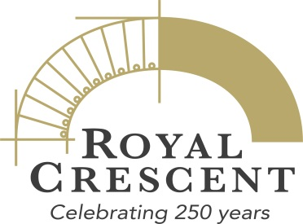

20 June 2017

Exhibition: A View of the Crescent – Celebrating the 250th Anniversary of Bath’s Landmark Building

An exhibition celebrating the Royal Crescent through the eyes of artists.

In this exhibition we explore what the Royal Crescent means to people who enjoy, admire and respond to the beauty of its setting, and how prominent artists have portrayed this famous building over the years through paintings, prints, photographs and textiles.

The Royal Crescent has housed royalty and national figures such as William Wilberforce, seen the drama of elopements and duels, been a setting for novels by Jane Austen and Charles Dickens, and provided a focus both in times of crisis and celebration. The Three Tenors have performed here, the Olympic Torch was paraded in 2012 and many film and TV productions use it. It has been bombed, blackened, ‘improved’ and repaired, and narrowly escaped being made a centre for local government in 1945. Today, 250 years since it was built, the Royal Crescent continues to inspire visitors and residents alike, who still find this masterpiece of Palladian architecture a place of fun and beauty, history and creativity.

The exhibition A View of the Crescent includes such diverse works as Thomas Malton's View of the Crescent (1777) lent by the Victoria Art Gallery, Peter Brown’s 2016 study of the Crescent lawn entitled The Beach and designer Carole Waller’s hand painted silk coat which features elements of the Crescent’s architecture and colours. The wall of historical photographs is mesmerising!

At No. 1 Royal Crescent from 24 June to 19 November.
Free with normal admission to the museum: Adult £10, Child £4, Family £22. Concessions.
Sponsored by Bishop Fleming and Crest Nicholson

ENDS

For further information please contact:

Janey Abbott, Communications Manager, Bath Preservation Trust
Telephone: 01225 338727 Email: jabbott@bptrust.org.uk
Royal Crescent 250

On 19 May 1967, the foundation stone for the Royal Crescent, the city's most iconic architectural landmark, was laid. This year Bath Preservation Trust, with funding support from the Heritage Lottery Fund (HLF), marks its 250-year anniversary with city-wide celebrations which include exhibitions, debates, community events, guided walks and artworks exploring the enduring power of a single building. Primarily focused on the Trust’s three city-centre museums: No. 1 Royal Crescent, the Museum of Bath Architecture and the Herschel Museum of Astronomy, there are also activities in partnership with Bath Festivals, RIBA South West and The Natural Theatre Company.

Use hashtag #royalcrescent250 to spread the word on social media.

About No. 1 Royal Crescent

No. 1 Royal Crescent is a Georgian town house that gives a unique insight into life in Georgian Bath. Built between 1767 and 1774 according to the designs of the architect John Wood the Younger, the Royal Crescent is justly considered one of the finest achievements in 18th-century urban architecture and represents the highest point of Palladian architecture in Bath. With over 60,000 visitors a year, the house provides an opportunity to look beyond the famous Palladian facade and see what life was like for the wealthy and their servants in 18th-century Bath.

No. 1 Royal Crescent is open 10.30am – 5.30pm every day, except Mondays, when open 12noon – 5.30pm. Adult tickets cost £10, children £4 and family and concession tickets are available.

www.no1royalcrescent.org.uk Twitter Facebook Instagram

About the Heritage Lottery Fund (HLF)

Thanks to National Lottery players, we invest money to help people across the UK explore, enjoy and protect the heritage they care about – from the archaeology under our feet to the historic parks and buildings we love, from precious memories and collections to rare wildlife. Website Twitter Facebook #HLFsupported.

About Carole Waller
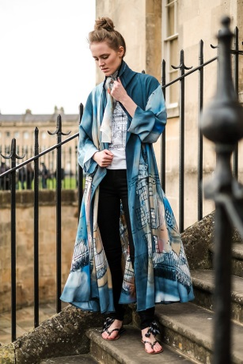
Carole Waller is a painter who specialises in painting with dye directly onto cloth for the purpose of making completely unique painted silk clothing – art to wear . She has perfected the art of painting directly onto silk, making a wearable and washable painting with incredible richness of mark and colour.
Her silk clothes are contemporary, stylish and timeless. The label is ‘I’m no walking Canvas’.

Twitter Facebook Website

Image: a model wearing the painted silk coat featuring in the exhibition

