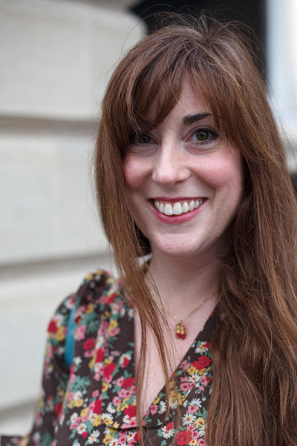
ALISON FARINA
Independent Theatre Practitioner
Playwright, Director, Performer
Artistic Director, Butterfly Psyche Theatre Company
Associate Director, The Rondo Theatre, Bath
Alison is a Bath-based theatre-maker, practitioner and playwright. She has had work commissioned and produced by both amateur and professional companies. Her canon of work includes eight full-length plays, various shorts and three family shows, all of which have been performed as The Rondo Theatre’s Christmas Show in Bath. These include; The Bluebird – Dec 2013, Return to Wonderland - Jan 2015 and The Snow Child - Dec 2015.
Her work has been performed Nationally in London, Bath, Whitstable, Isle of Man, Bristol, Exeter and Cheltenham and has had two separate regional tours of the Southwest from 2013 – 2015 for The Persistence of Memory (a play about Alzheimer’s) and The Tenant of Wildfell Hall (an adaptation of Anne Brontë’s classic). Internationally Alison’s work has been performed in Reykjavik, Iceland in 2014 (Fertility Objects,) and in Sonoma California in 2016 (The Bluebird).
Alison has a special interest in Heritage work and was commissioned by Temple Newsam House in Leeds to create Temple Tales (a five-episode Twitter script) in 2013 as well as writing their new, all-ages audio tour script in 2015. In 2017 she worked with Wiltshire Artists, Phoebe Kemp, as a development facilitator and writing mentor for Phoebe’s one-woman-show, May, about the Disabled Suffragette Activist, Rosa May Billinghurst, which premiers in Trowbridge in February 2018.
In 2017 Alison was long-listed for the 2017 Salisbury Playhouse Theatre Fest West Prize for her play Seven Tears by Moonlight and her script Orpheus and Eurydice won GOLD at the 2017/18 Bristol, Bath and Somerset Tourism Awards for ‘Tourist Experience of the Year’ at the Clifton Suspension Bridge Vaults.

