at Bath Preservation Trust Museums
FREE admission to the museums during Museums Week with a valid Discovery Card, otherwise normal admission charges apply.
Herschel Museum of Astronomy
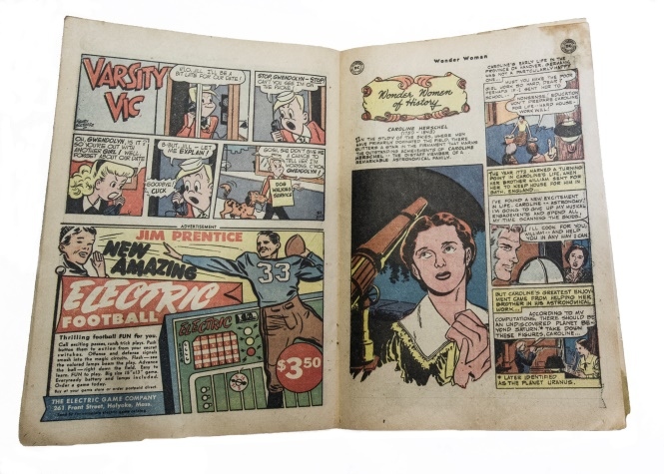
Design a Space Superstar!

27 Oct – 4 Nov

1.00 – 5.00pm on weekdays

10.00am – 5.00pm at weekends

Our current exhibition ‘Wonder Women of Science’ features a comic book about Caroline Herschel, a Georgian Astronomy genius. Create your own Superhero or Superheroine of Science – what powers will you give them?
Get creative with our poster outlines and exciting graphics.

Planisphere Perfection!
31st Oct
1.00 – 4.00pm
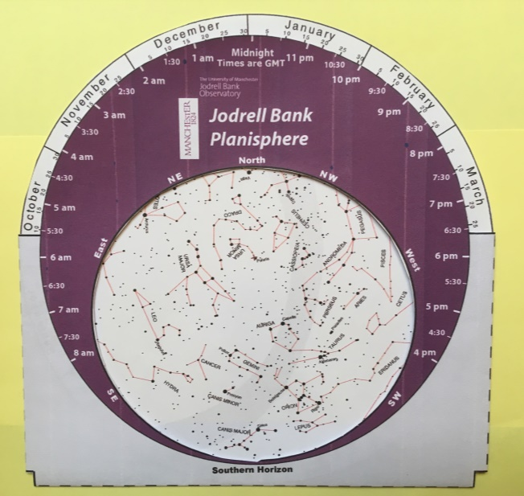
A planisphere is a device that shows which stars are visible in the night sky at any particular time. Take a look at the Georgian example in our exhibition ‘Wonder Women of Science’ then make your own so that you can easily identify constellations.

TALK: So you think you want to be a scientist?
31st Oct
2.00 – 3.00pm at No. 1 Royal Crescent
Free to Discovery Card holders although tickets must be booked in advance

Carole Mundell, Professor of Extragalactic Astronomy and Head of Astrophysics at the University of Bath, will give a talk about her work, followed by a Q&A session.
In 2016 she established a new Astrophysics research group, concentrating on high-energy extragalactic astrophysics of black hole driven systems and their environments. Professor Mundell is involved with several campaigns to improve representation of women in astronomy.
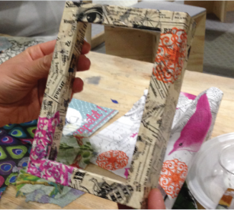
No. 1 Royal Crescent

Design a Bath-themed Photo Frame to take home

27 Oct – 4 Nov

10.00am – 5.00pm
In our current exhibition ‘Women’s Suffrage 100: Freedom & Fight in Bath’, you can see old photographs of Bath by Lesley Green-Armyitage. Make a Bath-themed frame to take home to display your favourite photo.

Make a giant Banner and join the parade!

30 Oct 10.00am – 1.00pm
Take part in making a giant banner which celebrates the people who help to keep Bath a special and beautiful city. Add your own collage, paint and textile effects and, if the weather’s good, join us to parade the banner along the Royal Crescent at one o’clock!

Museum of Bath Architecture

Decorative Printing workshop

29 Oct 1.00- 4.00pm
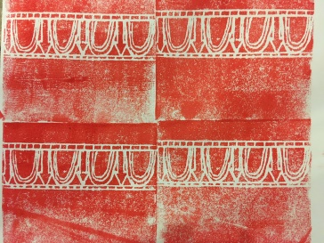
Look around the museum to spot our examples of beautiful and elegant wallpaper and plasterwork patterns. Then design and produce your own Georgian inspired prints using stampers or polystyrene tiles and printing ink.

