This access statement does not contain personal opinions as to our suitability for those with access needs, but aims to accurately describe the facilities and services that we offer all our guests/visitors.
Access Statement for No. 1 Royal Crescent, Bath
Introduction
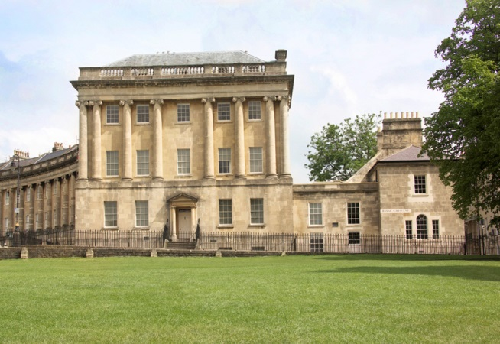
Situated in the beautiful Georgian City of Bath, No. 1 Royal Crescent is a magnificently restored Georgian town house that creates a picture of life in the 18th century.
Come in for free to visit the Introduction Room, see exhibitions in the Brownsword Gallery and browse in the Georgian shop; these are based on two floors with level or lift access to all galleries and facilities.
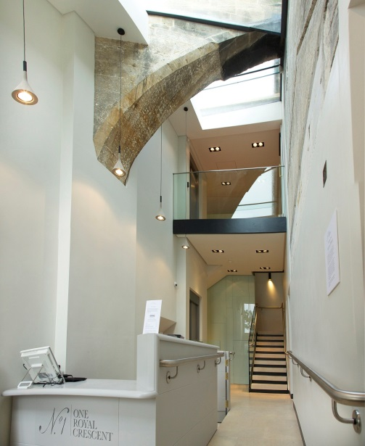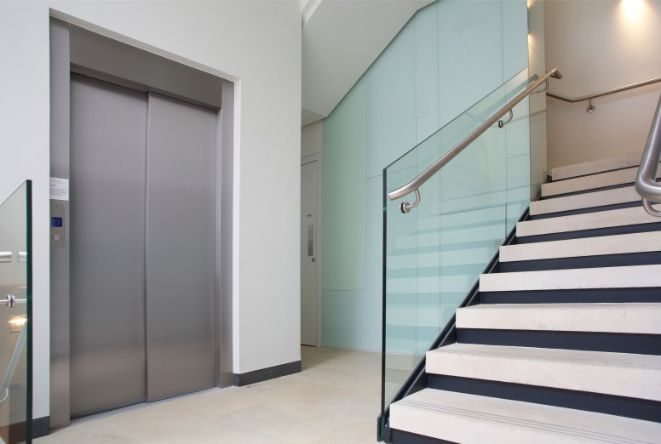
No.1 Royal Crescent museum gives visitors a vibrant and immersive experience of how people lived 250 years ago – both above and below stairs.
Volunteer guides in each room provide information on exhibits and are available to provide assistance to visitors.
We look forward to welcoming you. If you have any queries or require any assistance please phone 01225 428126 or email no1royalcrescent@bptrust.org.uk.
Pre-Arrival
- For full details and maps of how to reach us and what is on, please see our website at www.no1royalcrescent.org.uk. Alternatively, you can plan your journey by car or public transport using www.transportdirect.info; simply enter your postcode and ours, which is BA1 2LR, to get directions.
Car Parking and Arrival
- The museum has no car park. A map of Bath car parks is here.
- There is a designated accessible parking bay for Blue Badge Holders in Brock Street, two minutes away along a level pavement.
- Pay and Display bays (up to 1 hr) are situated on Upper Church Street, a two minute walk away.
- Long Term Parking (4 hours or more) is available in Charlotte Street Car Park, which is five minutes’ walk away. The walk is up an incline so could take longer. There are many designated accessible bays near the car park entrance.
- The nearest railway station is Bath Spa Railway Station. It is just under a mile walk and takes 20 minutes.
- Taxis are available at the station. If you require an accessible taxi you can book this in advance. See contact information for details.
- The nearest bus stop is 500m from the museum (10 minute walk). Take the No 1 or No 6 from Bath Bus Station to Alfred Street (on Lansdown Hill). To return take No 1 or No 7 to Bath Bus Station. Buses run approximately every 10 minutes. All buses are accessible and can accommodate one wheelchair.
- Alternatively take the Hop On Hop Off red Tour Buses from City Sightseeing Bath, which have a stop outside the museum. The low floor buses are suitable for wheelchair access.
Main Entrance, Reception and Tickets
- The main entrance is into the Servant’s Wing, the two storey extension to the rear of No. 1 Royal Crescent.
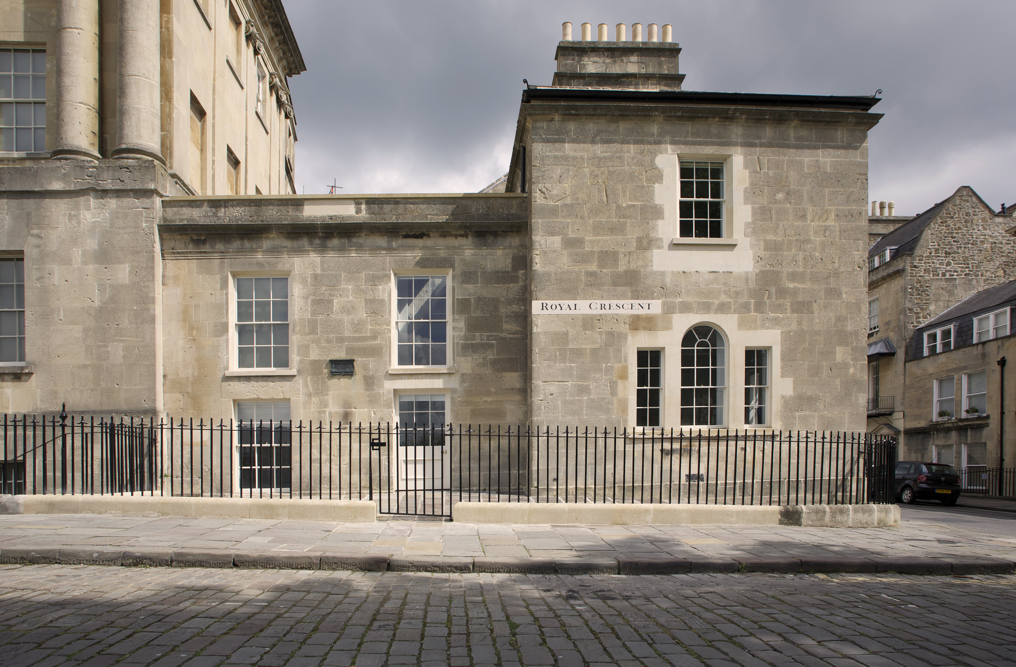
- The glazed entrance door is reached across sloping Yorkstone paving. The entrance door has a level threshold, a round knob handle and a doorbell, if assistance is required.
- Inside the reception desk has a reduced height counter.
- Induction loop available for viewing and hearing the introductory video on iPad.
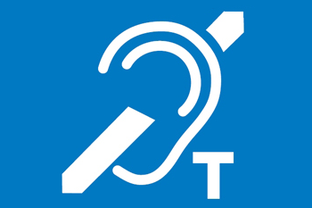
- An Access Leaflet is available showing floor plans of the four floors of the museum, the suggested order for visiting the house, the location of toilets, stairs and indicating the recommended route and the step free route.

Galleries and displays
- Allow an hour or more to see the rooms and exhibits on display.
- The Introduction Area has displays about No. 1 Royal Crescent. This room is reached from the reception desk up a 200mm high step at its doorway. The wheelchair accessible route to this room is via a ramp and through the shop. The 1:12 gradient ramp has a limestone floor surface, handrails on both sides and 1.1m width.
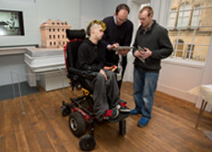
- The Brownsword Gallery at first floor level is reached up a new limestone staircase with three flights and 20 steps. The stairs have two continuous handrails and the nosings are identified using inserted metal strips.
- The lift to the first floor gallery is entered at ground floor level near the foot of the stairs to the first floor. It is a standard 4 person passenger lift with a car size of 1100mm x 1400mm. It has tactile and Braille buttons.
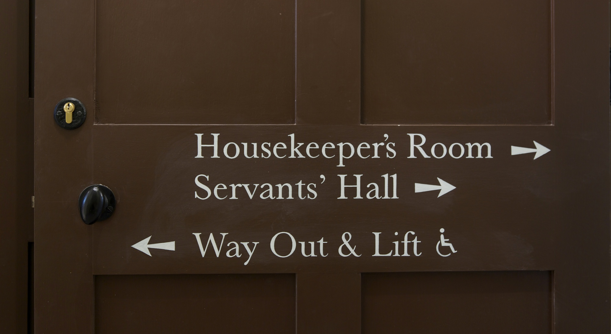
- Once at the upper lift and stair landing, the Brownsword Gallery is entered through an automatic glazed entrance door. The push pad to open the door is located behind you, near the lift buttons. The gallery rooms have wooden boarded floors and display cases at a variety of heights. The openings between the two rooms have been widened to enable easier wheelchair circulation.
Public Toilets
- There is a standard WC cubicle with inward opening door, entered from the ground floor foyer. It has a fold-down nappy changing table inside the cubicle.
- The unisex wheelchair accessible cubicle is half a floor level below the reception area, reached via the passenger lift or down a straight flight of steps. These steps have contrasting protruding nosings, which may present problems for people wearing callipers.
- The WC cubicle has an outward opening door and an emergency alarm cord.
- There are vertical rails either side of the basin, and vertical, horizontal and drop-down rails adjacent to the WC pan.
- The white sanitary fittings and stainless steel grabrails contrast against the grey walls. The WCs are well lit.
- The cubicles have dark grey non-slip flooring.
- There are lever taps on the sinks.
Shop
- The shop is level throughout. It is not a very large room, but there is sufficient space for a wheelchair to circulate.
- The serving counter has an acceptable reduced height section.
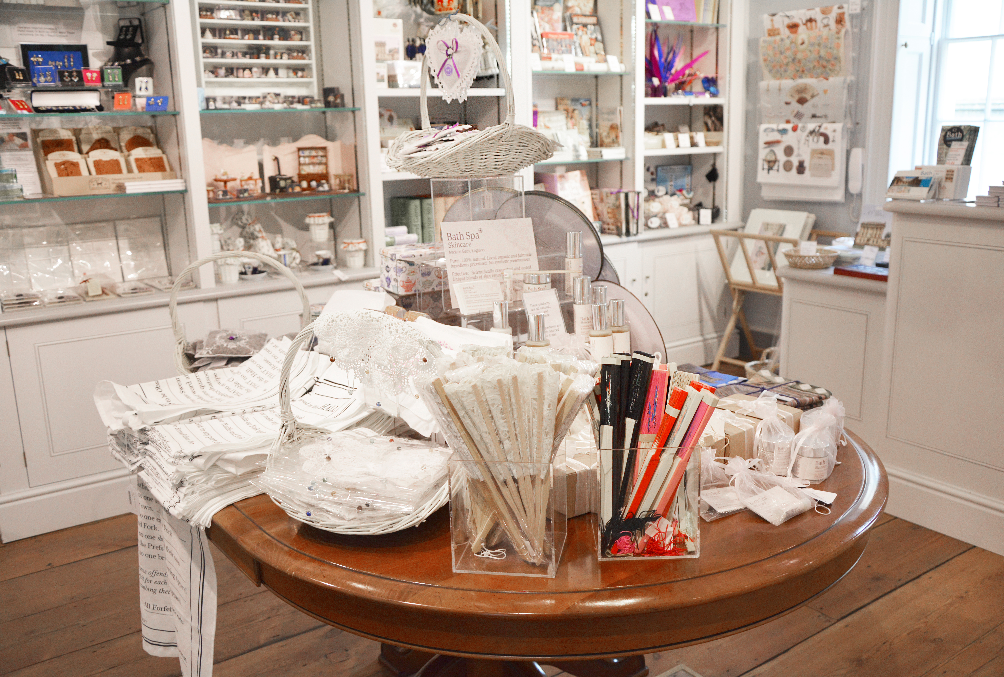
- Many of the goods for sale are displayed at a height accessible from a seated position; however staff members are able to offer assistance, if there are any items displayed out of reach.
Additional Information
- Refreshment facilities are not available at the museum.
- There is level access from the passenger lift to the ground floor and basement of the main part of the house. The second and third floors are not wheelchair accessible, but can be interpreted via a hand-held iPad, available at the reception desk.
- Assistance dogs are allowed.
- A baby carrier is available to borrow.
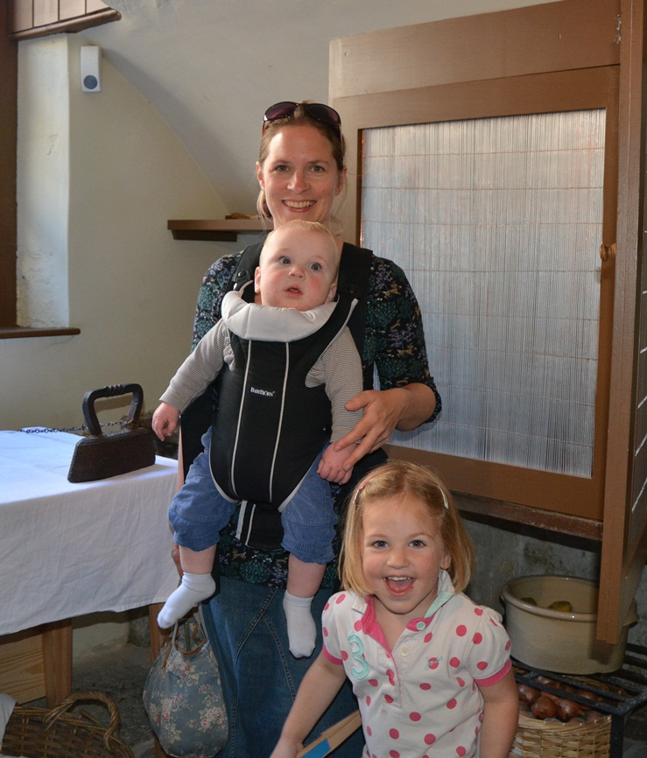
- Within the museum there is no room to accommodate mobility scooters. Inside the railings near the front door there is space for them to be left at their owner’s risk.
Contact Information
Address 1 Royal Crescent, Bath BA1 2LR
Telephone: 01225 428126
Email: no1museum@bptrust.org.uk
Website: www.bath.preservation.trust.org.uk
Grid Reference: ST 74569 65329
Hours of Operation: Mon 12.00-5.30pm, Tues-Sun 10.30am-5.30pm
Parking: Bath and Northeast Somerset Council Website: http://www.bathnes.gov.uk/services/parking-and-travel/car-parks
Local Accessible Taxi: Abbey Taxis – 01225 444444
V Cars – 01225 464646
Local Public Transport: Bath Bus Company: 01225 330444
Bus Station, Dorchester Street: 01225 464446
City Sightseeing Bath 01225 444 102

